Media Kit: CLIMATE CHANGE KITCHEN

Contents:

Short Book Description
Long Book Description
Short Author Bio
Long Author Bio
Book Reviews
Sample Interview Questions
Shareable Links
Contact Information
3D Book Cover Image
Author Photos
Shareable Images
Preface

Short Book Description
CLIMATE CHANGE KITCHEN is a unique cookbook that’s good for you and good for the planet. Sixty-five of the world’s most popular dishes, both meat and plant-based, with each recipe hacked to lower the carbon footprint, reduce the calorie count, and provide a better balance of nutrients with no compromise on taste. Step into a hot kitchen for a cool planet.
Long Book Description
The CLIMATE CHANGE KITCHEN will show you how simple changes to your favorite recipes can create great tasting food that’s good for you and good for the planet. Sixty-five of the world’s most popular dishes, both meat and plant-based, with each recipe hacked to lower the carbon footprint, reduce the calorie count, and provide a better balance of nutrients with no compromise on taste. Climate Change Kitchen is packed full of mouth-watering recipes; from sumptuous sharing plates and hearty soups to summer salads, winter warmers, comfort food classics, soul bowls, and all your favorite fake-aways. Step into a hot kitchen for a cool planet.
Short Author Bio
Dr Mathew Hampshire-Waugh is a former director at a global investment bank where his work focussed on renewables, electric cars, batteries, and biofuels. The author gained his doctorate in materials chemistry from UCL, working on nanomaterials to enhance the performance of energy-saving windows and solar panels. His best-selling book ‘CLIMATE CHANGE and the road to NET-ZERO’ is a non-fiction analysis of the science, technology, economics, and politics of climate change and the low carbon transition.
Whilst much of the transition will be driven by emerging technology, reaching net-zero food and agriculture will rely more heavily on cultural change. Mathew started thinking, “is it possible to continue to celebrate and enjoy the world’s favorite recipes whilst also protecting the planet?”
This question became the inspiration for his latest book the CLIMATE CHANGE KITCHEN. The idea, to combine his experience in chemistry and finance with a love of cooking - to crunch the numbers, carbon-hack classic recipes, and re-imagine the world’s favorite dishes for a low-carbon future.

Long Author Bio
Dr Mathew Hampshire-Waugh has spent the last ten years working as an equity analyst at global investment bank. He resigned his role as director in 2019 to commit to writing on climate change and new energy technology full time.
During a decade as an investment banker, Mathew Hampshire-Waugh has worked with the top executives of many multi-billion-dollar companies, and built relationships with many of the world’s largest investment managers. Mathew’s work centred on forecasting technology trends, financial performance, and the intrinsic value of companies involved in markets including renewable energy, electric cars, battery technology, and biofuels. His role was to publish and pitch share price recommendations to the world’s largest institutional investors, hedge funds, and private wealth managers.
Prior to his career in the banking industry, Hampshire-Waugh gained his doctorate in materials chemistry from University College London, where he worked on novel coatings and nano-materials for use in energy saving glazing and solar panel design. During his doctorate Mathew registered a patent for an efficiency enhancing coating for solar modules, published numerous scientific papers, and engaged in public speaking, consultancy, and media outreach for the BBC, Teachers TV, and other outlets.
His last best-selling book ‘CLIMATE CHANGE and the road to NET-ZERO’ was a non-fiction analysis of the science, technology, economics, and politics of climate change and the low carbon transition. Hampshire-Waugh concluded that a rapid transition to a low-carbon system was a win-win for both the environment and the economy. Whilst much of the transition will be driven by emerging technology, reaching net-zero food and agriculture will rely more heavily on cultural change.
The author started thinking, “is it possible to continue to celebrate and enjoy the world’s favorite recipes whilst also protecting the planet?”
This question became the inspiration for his latest book the CLIMATE CHANGE KITCHEN. The idea, to combine his experience in chemistry and finance with a love of cooking - to crunch the numbers, carbon-hack classic recipes, and re-imagine the world’s favorite dishes for a low-carbon future.

Alternate Author Bio

“Dr Mathew Hampshire-Waugh spent ten years as an equity analyst at a global investment bank working on new energy technologies and associated supply chains. He resigned his role as director in 2019 to commit to writing on climate change and new energy technology full time. Mathew is the author of bestselling book ‘Climate Change and the road to Net-Zero’: a data-led dive into climate change and possible solutions covering the science, technology, economics, and politics of the energy transition. He is founder of Net-Zero Consulting Services LTD.
Prior to his career in the banking industry, Hampshire-Waugh gained his doctorate in materials chemistry from University College London, where he worked on novel coatings and nano-materials for use in energy saving glazing and solar panel design. During his doctorate Mathew registered a patent for an efficiency enhancing coating for solar modules, published numerous scientific papers, and engaged in public speaking, consultancy, and media outreach.”

Sample Interview Questions
- What inspired you to write a cookbook?
- Why are food choices so important?
- What is more important the type of food we eat or where it comes from?
- Why isn’t this a vegan cookbook?
- What is the most surprising thing you learnt from writing a low carbon cookbook?
- What is the one cooking tip you would give?
- How big a difference does our food choices really make?
- Where do food emissions come from?
- Are avocados as bad as we think?

Shareable Links
www.climatechangekitchen.com
https://net-zero.blog/recipes
https://net-zero.blog/author
www.crowstonepublishing.com

Contact Information
Mathew Hampshire-Waugh
hampshirewaugh@net-zero.blog

3D Book Cover Image

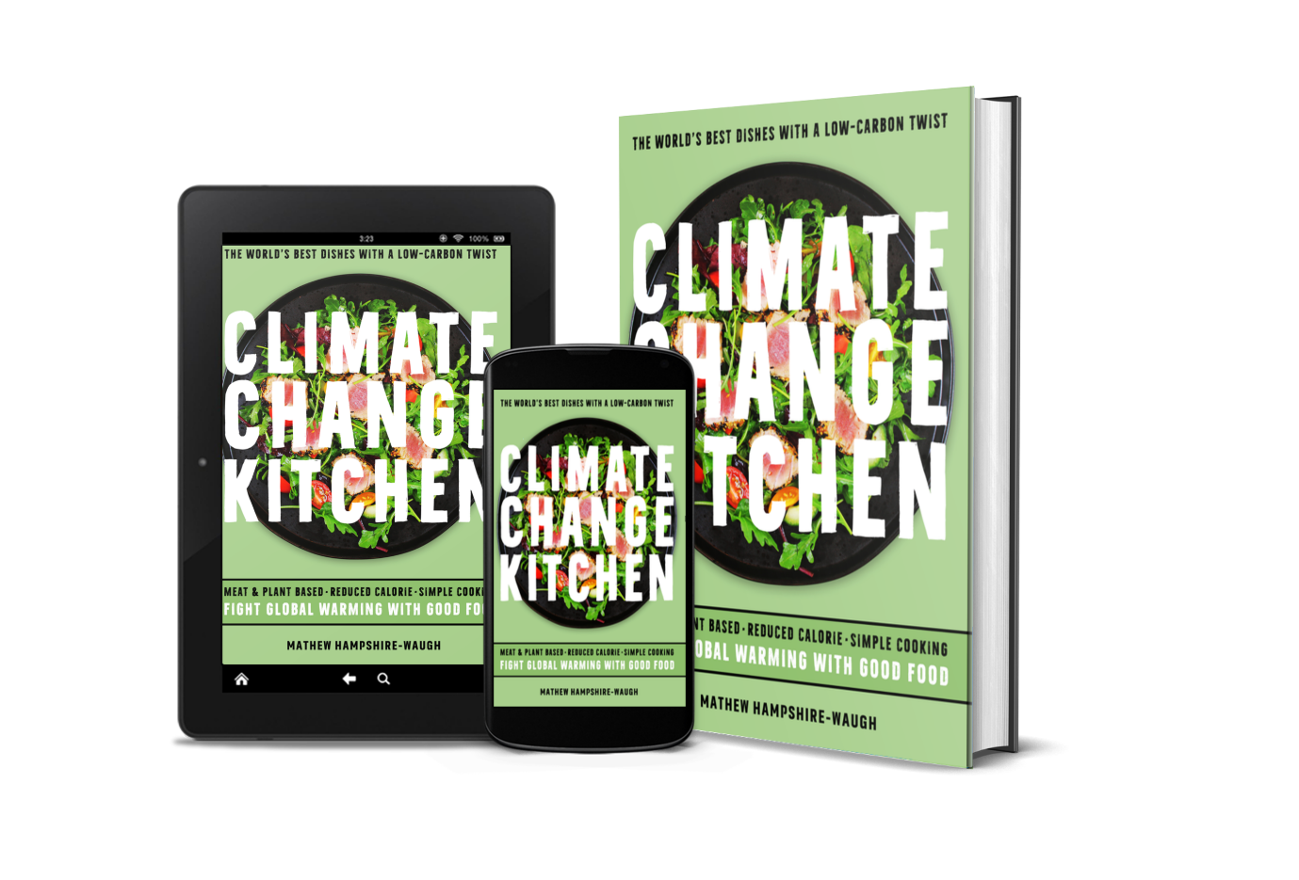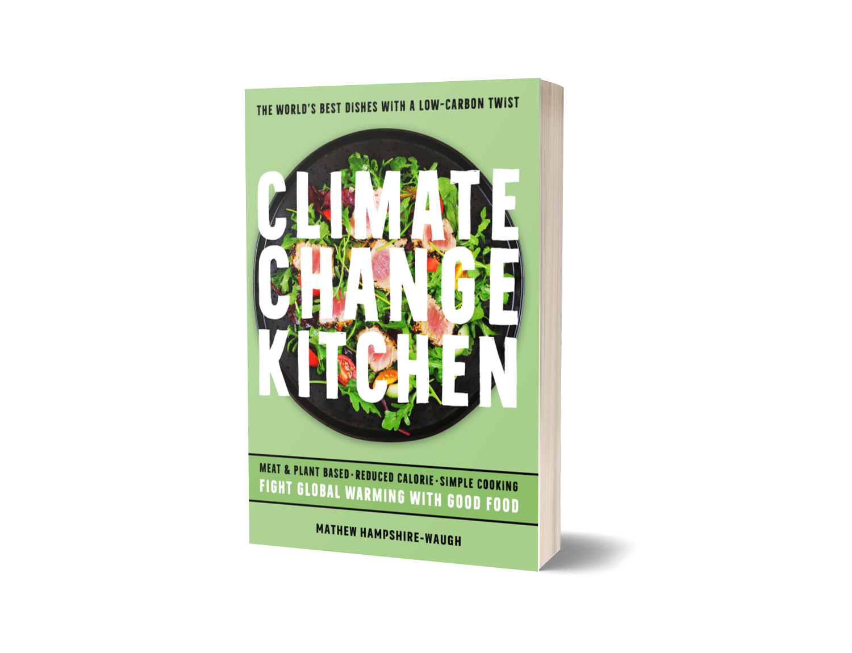

Author Photos
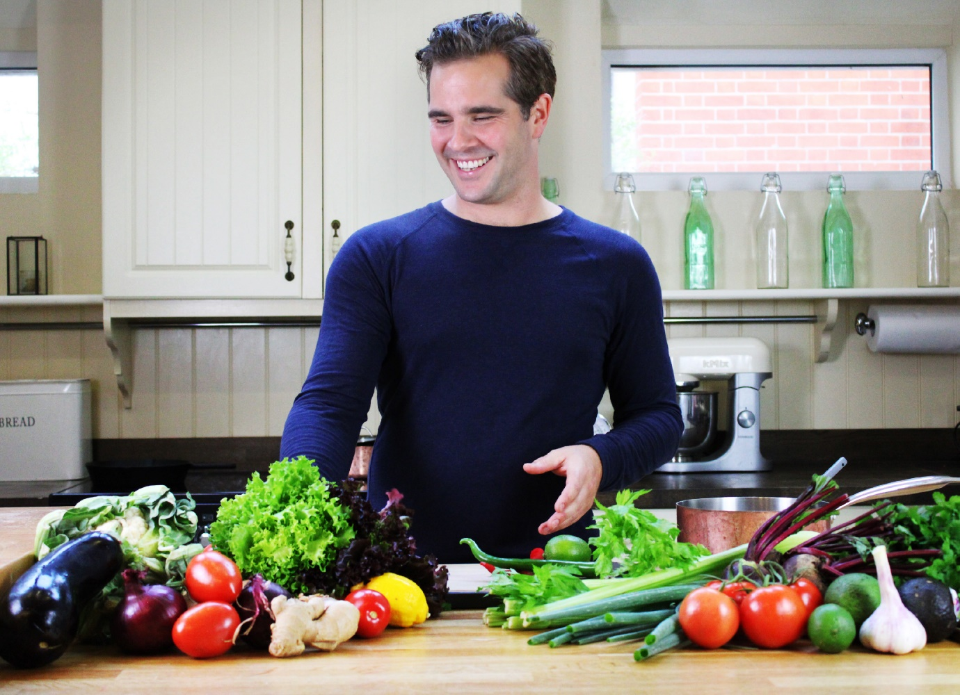
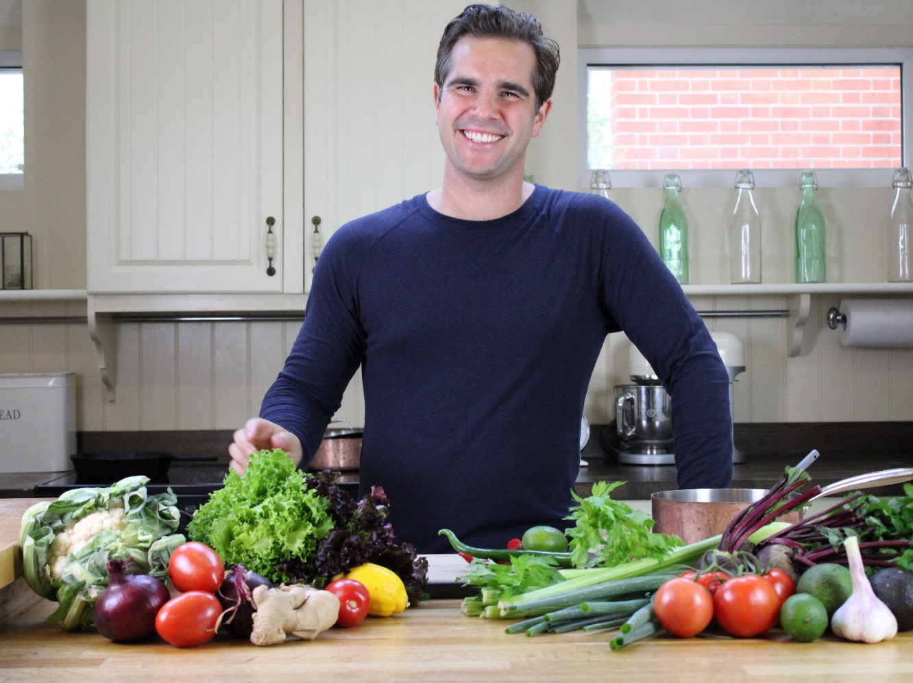
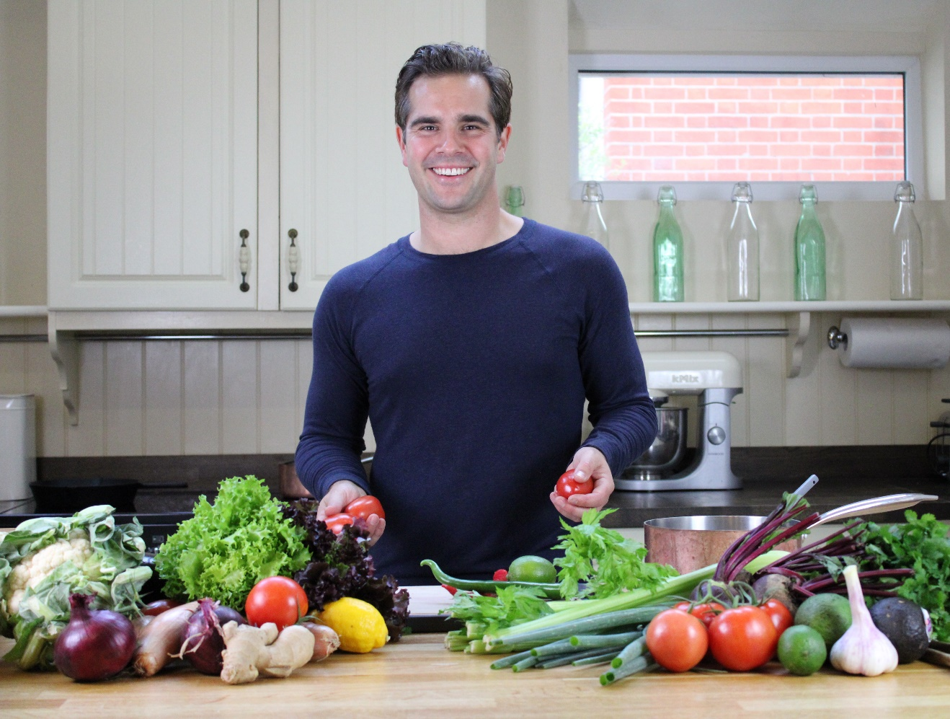

Shareable Images

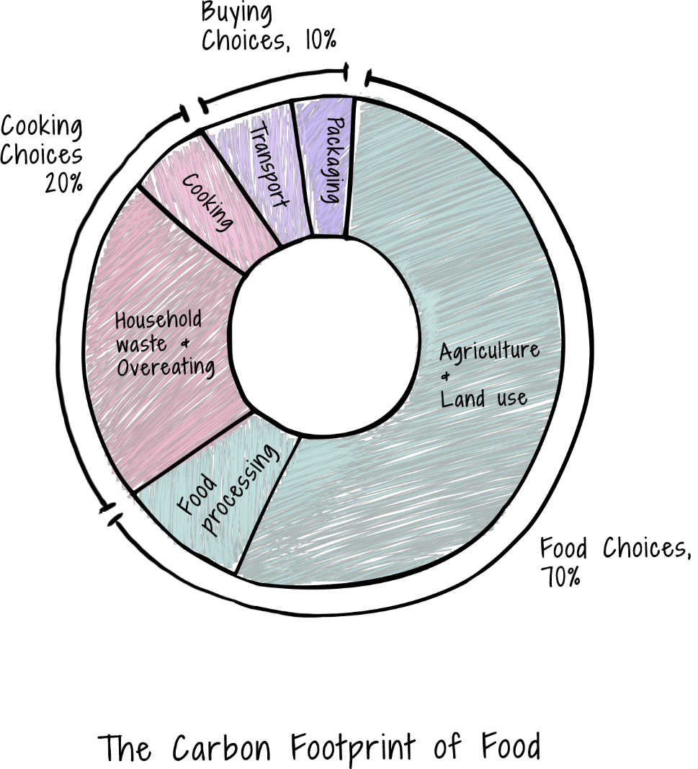

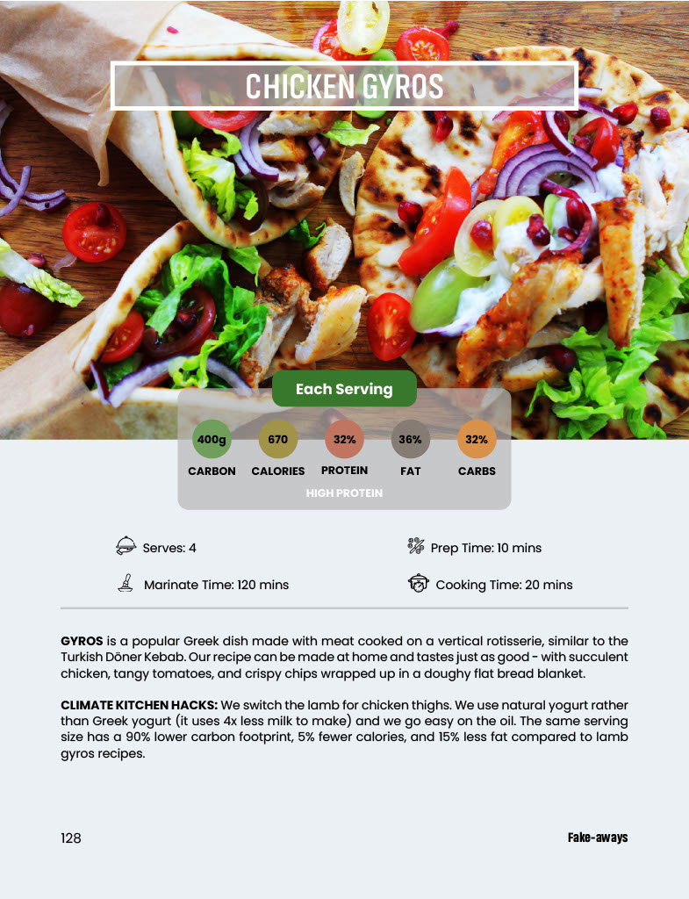

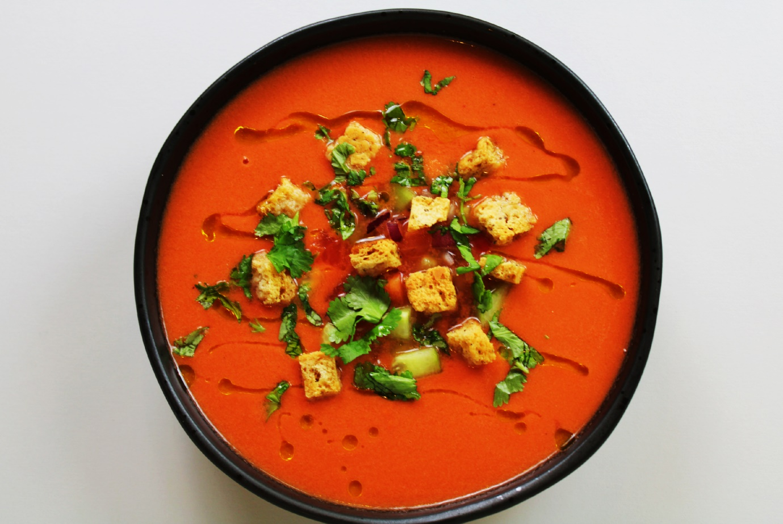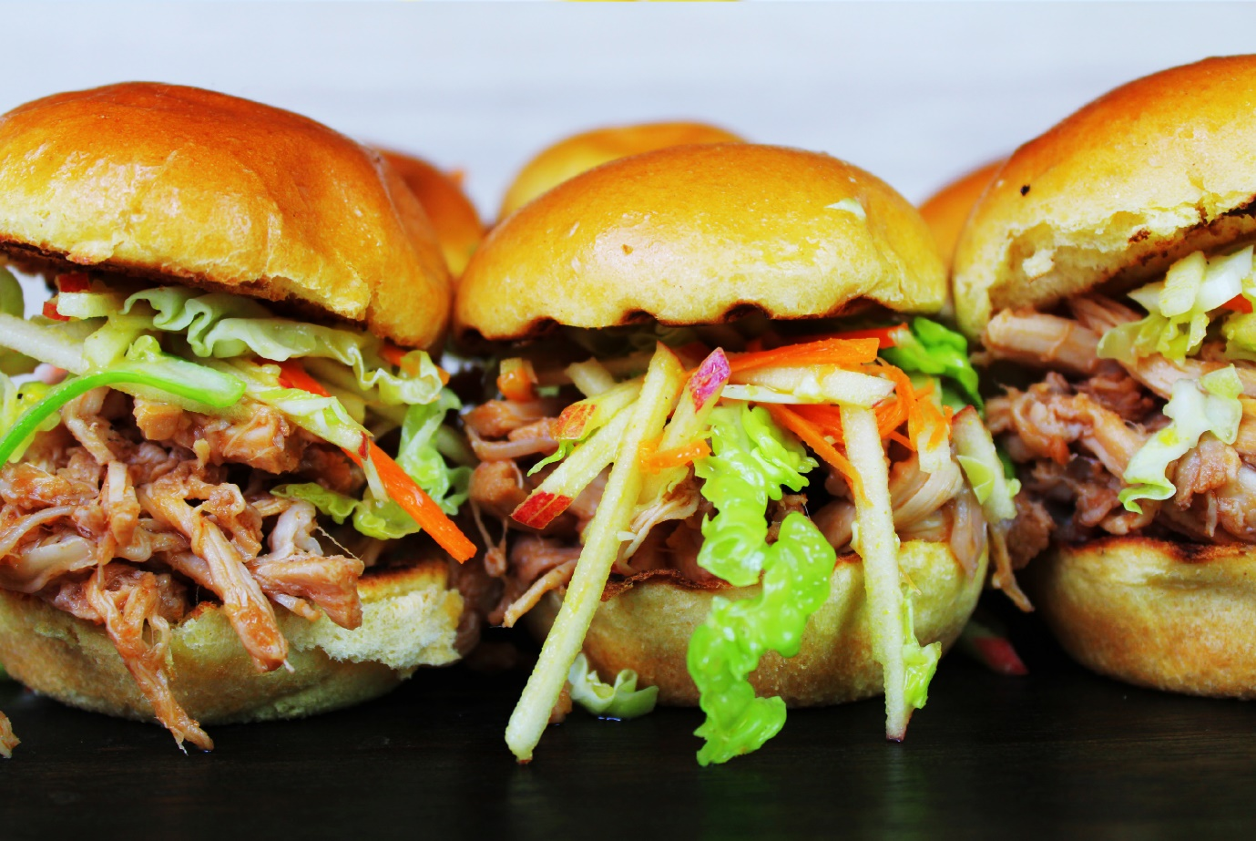
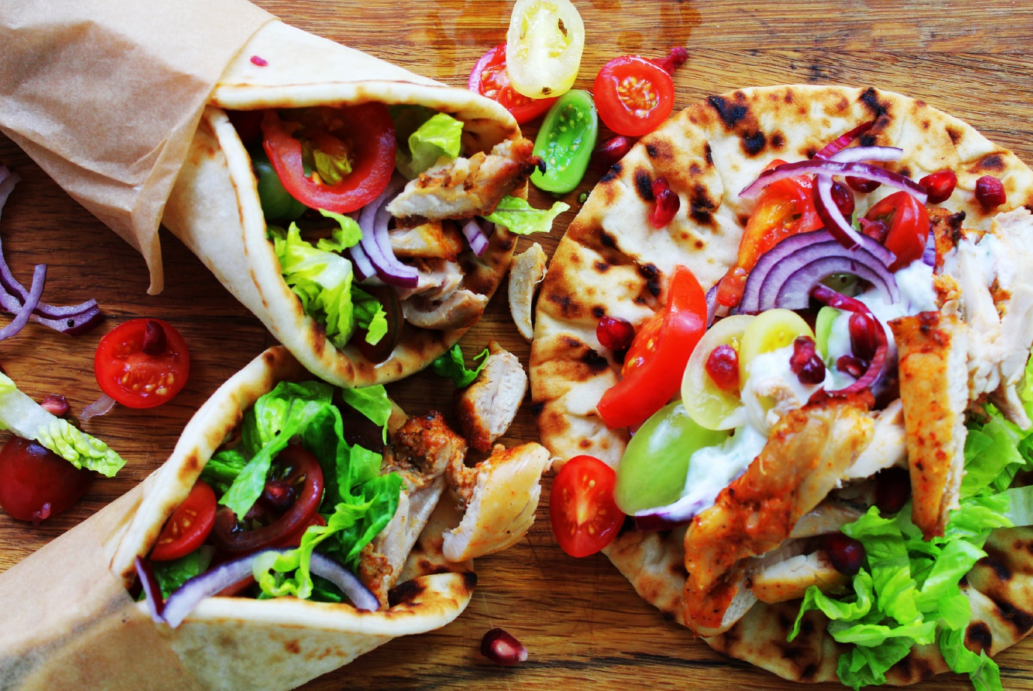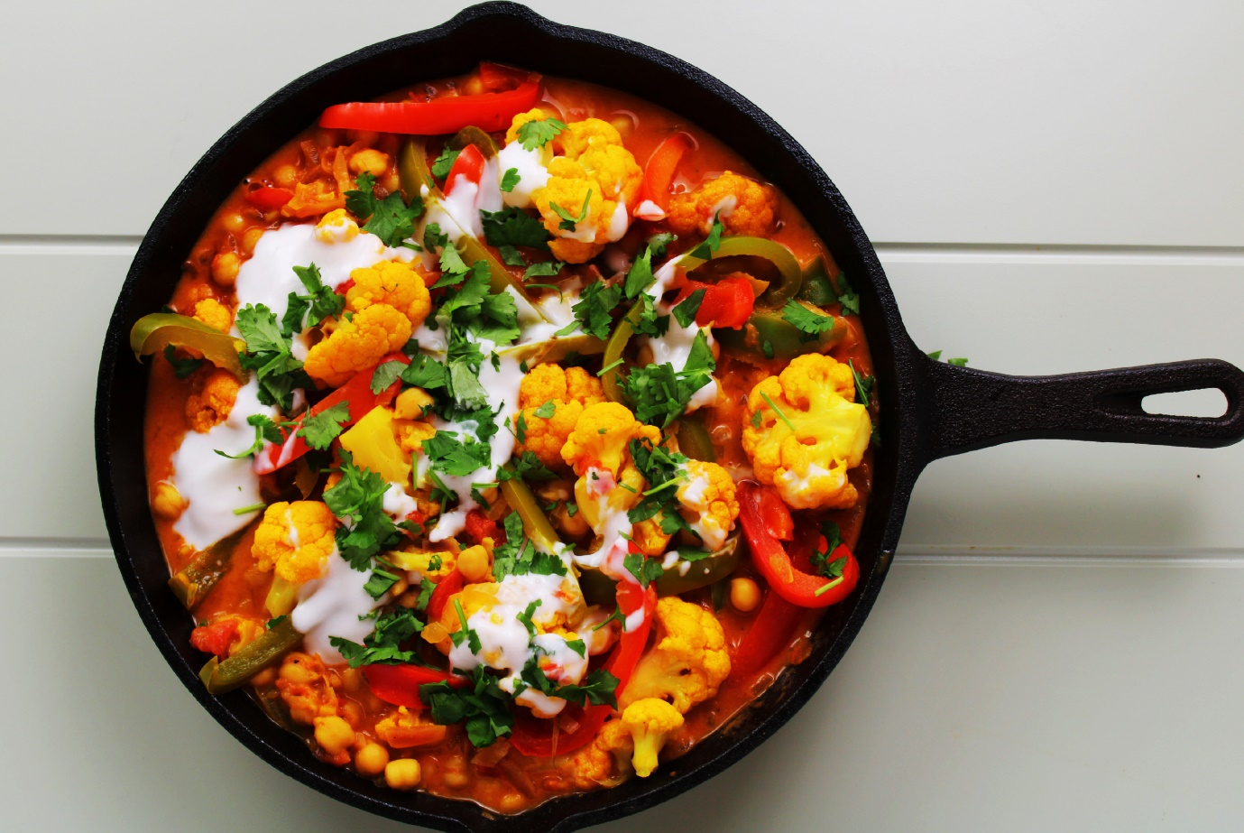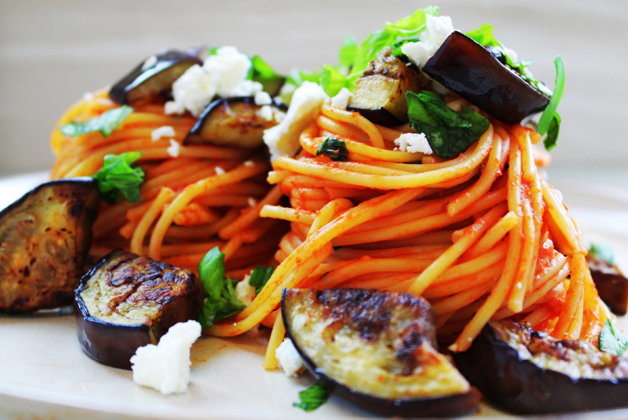
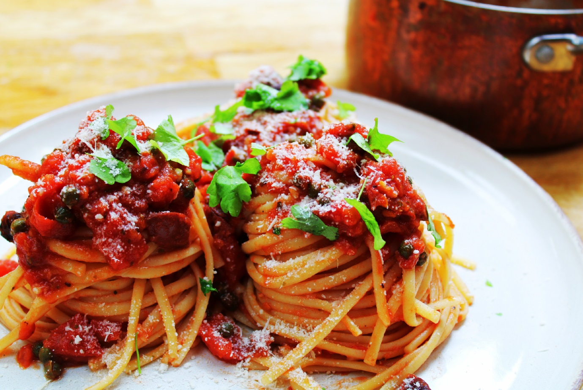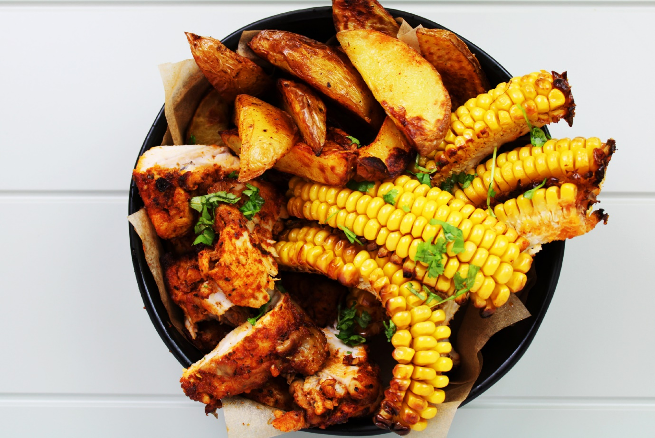
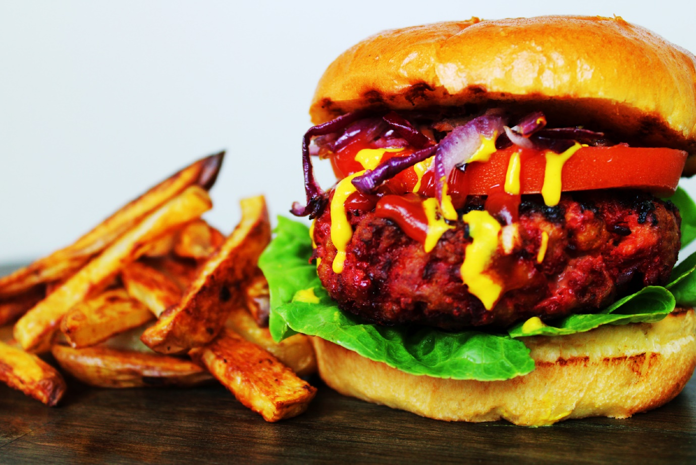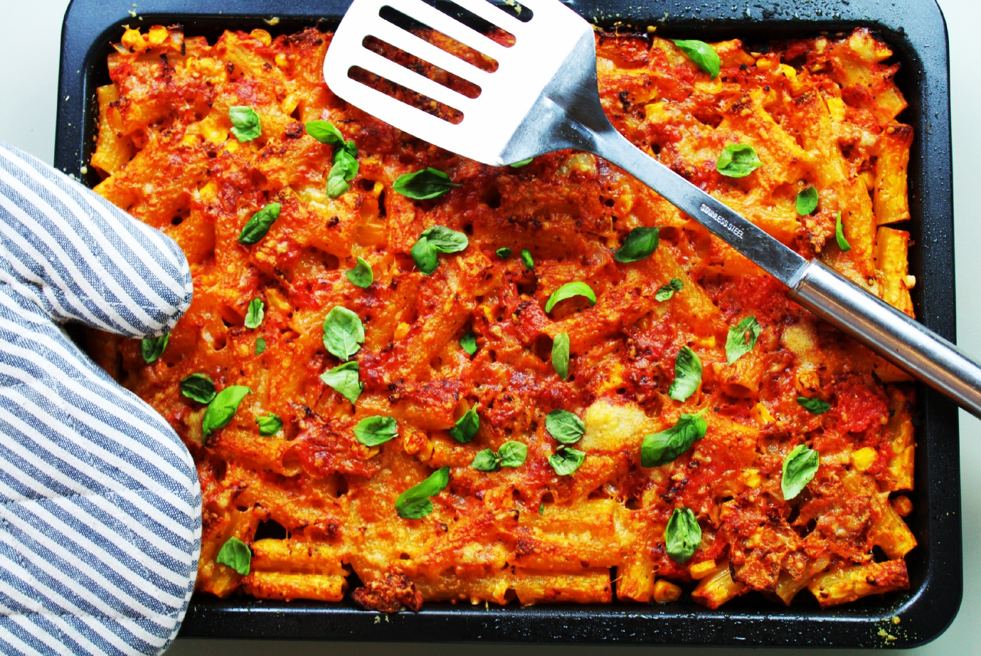

Preface

Creating the Climate Kitchen
If you had told me twenty or even two years ago that I was going to write a cookbook I wouldn’t have believed you. My career started out in science, where I earned a doctorate in chemistry researching ways to improve solar panels, before spending ten years working on electric cars and renewable energy at a global investment bank.
I always held a deep interest in climate so in 2019 I decided to take the plunge. I quit my job and spent three years researching and writing a non-fiction book on all aspects of global warming. My book ‘CLIMATE CHANGE and the road to NET-ZERO’ shows that a rapid transition to a low-carbon system is not only best for the planet but also the economy. Since publishing the book, I have been working hard to share that message with investors, companies, and environmental groups.
I can now see a clear path to net-zero through new technologies across many of our global systems. But agriculture is very different. Reaching net-zero food will rely more heavily on cultural change in our everyday food choices and eating habits.
I began to ask myself, is it possible to continue to celebrate and enjoy the world’s favorite recipes whilst also protecting the planet?
This question became the inspiration for the Climate Change Kitchen. The idea, to combine my experience in chemistry and finance with my love of cooking - to crunch the numbers, carbon-hack classic recipes, and re-imagine the world’s favorite dishes for a low-carbon future.
The Climate Change Kitchen recipes have, on average, a 75% lower carbon footprint, 20% fewer calories, and 40% less fat with the same serving size and amazing taste. Cook each of the 65 recipes in this book once (instead of the traditional recipes) and you will avoid half a tonne of green-house gas emissions.
GOOD FOR YOU AND GOOD FOR THE PLANET

Mathew Hampshire-Waugh

Good For You
Everyone knows that eating well is key to a healthy, happy lifestyle but making the correct food choices can often be confusing, especially when cooking at home. That’s why all the recipes in the Climate Change Kitchen come with a calorie count and a breakdown of nutritional content. The recipes have also been ‘hacked’ not only to lower the carbon footprint, but also to reduce the calorie content and improve the balance of protein, carbohydrates, and fat. Helping you enjoy delicious meals which are good for you and good for the planet.
Counting Calories: The recommended daily calorie (kcal) intake for your average healthy adult is 2,000 - 2,500 calories. This should include 6-8 glasses of water and at least 5 portions of fruit & veg per day. General advice is to eat less red or processed meat, smaller quantities of sugary treats, and to avoid saturated fat, whilst eating more beans & pulses and choosing unsaturated oils like olive or canola oil.
Balancing Nutrients: Fat, protein, and carbohydrates are collectively known as macronutrients, the food sources that provide us with energy (calories). A healthy diet consists of a balanced intake of macronutrients with roughly 15% of calories from protein, 30% of calories from fat, and 55% of calories from carbohydrates.
Keeping Count: Trying to eat healthy? The Climate Kitchen has got you. All our recipes provide a clear calorie count per serving, the balance of macro-nutrients as a percentage of calories, and labels on all recipes that qualify as: vegetarian, vegan, low calorie, low fat, low in saturated fat, low-carb, or high in protein. Helping you make more informed food choices with all your favorite recipes.

Good for the Planet
Agriculture is responsible for one quarter of all global greenhouse gas emissions. Half of agricultural emissions come from the carbon dioxide released when forests are cut down to make way for expanding agricultural land. The other half from excess fertilizer use, cow and sheep burps, and the burning of fossil fuels for farm equipment, refrigeration, and transport.
To avoid the worst impacts of climate change agriculture must reach net-zero by the middle of this century. We must eliminate ongoing agricultural emissions and reverse the expansion of farmland.
Some of the required changes (such as improving production yields, reducing supply chain waste, and low carbon farming techniques) must be driven by governments and the farming industry. But individual changes will also play a large role in decarbonizing agriculture through our everyday eating choices:
Food Choices: The type of ingredients you eat have the biggest impact on the carbon footprint of the food system. Food choices influence the emissions from land-use, farming, and food processing which together account for 70% of the carbon footprint of our food.
- Meat products have the highest carbon footprint owing to the large area of land needed to rear animals. In fact, two thirds of all agricultural land is used for animal grazing and just one third is used for growing crops (half of which are then fed to animals). Yet, despite the meat industry using nearly one quarter of dryland on planet Earth, meat provides just 20% of our daily calorie intake.
- Beef and lamb have the highest carbon footprint of all foods because cows and sheep have a unique way of digesting food that releases large quantities of methane - a particularly potent greenhouse gas. The methane from cows and sheep alone accounts for 5% of all global greenhouse gas emissions - that’s nearly as much as deforestation.
- Fish: Emissions come from the diesel burnt to power the boats, destruction of the ocean floor during bottom trawling, and in processing and transporting the fish. Always opt for locally-sourced, sustainably certified fish caught by handline, pole and line, or troll fishing where possible.
- Plant-based products have the lowest carbon footprint - grains, rice, vegetables, and fruit require less land, less processing, and create less waste. Field-grown, seasonal, locally sourced plant-based products have the lowest footprint of all.

Cooking Choices: Food waste and the energy used during cooking accounts for 20% of the carbon footprint of food. Reducing waste, particularly in the higher emissions ingredients, is very important. Reducing food waste also ties into the importance of portion control for a healthy lifestyle. The way you cook food generally has a smaller impact on carbon emissions but moving away from natural gas and towards electric cooking equipment supports decarbonization efforts and eliminates the harmful air pollutants released into your kitchen from burning natural gas.
Buying Choices: It may come as a surprise but the transportation, refrigeration, and packaging of food account for just 10% of the total carbon footprint. Buying locally sourced, seasonal produce with sustainable packaging helps support efforts to decarbonize the food system - but don’t forget it’s the type of food we eat which has a far bigger impact on fighting climate change.
The Carbon Footprint of Food

Climate Kitchen Hacks
Each of the classic recipes in the Climate Change Kitchen has been ‘hacked’ to lower the carbon footprint, reduce the calorie count, and improve the balance of protein, carbohydrates, and fat. Our simple labelling system makes cooking great tasting, healthy and sustainable food super easy.
Here are some of the key principles which guide us at the Climate Change Kitchen:
800 is the Magic Number: Each of our main meal servings is less than 800 calories with a carbon footprint of less than 800 grams. Why? Well, 800 calories is around the maximum recommended calorie count for the main meal of the day for a healthy adult. And 800 grams of carbon dioxide (CO₂) is less than half the average carbon footprint of a main meal today. If you combine this small but crucial change with bigger systems changes and reforestation, you are supporting a pathway to net-zero agriculture (starters, soups, and salads are all less than 400 calories & 400 grams of CO₂ per serving).
Eat Your Greens, Green Your Eats: Switching from meat to plant-based ingredients is a sure-fire way to lower the carbon footprint and lower the calorie count of a dish. By using high-protein, plant-based ingredients you can create great tasting, nutritionally balanced and low carbon versions of your favorite meals. Jack fruit, sweet potato, beans, pulses, avocados, peas, and nuts are great substitutes, with a lower carbon footprint and packed with flavor.
Choice Meats, Meat Choices: Here at the Climate Change Kitchen we get it - you still want to enjoy cooking and eating meat. We’ve got your back. By making smart meat choices you can dramatically lower the carbon footprint of your favorite dishes and improve nutritional balance. Switching out beef, lamb, or goat and replacing them with pork, chicken or seafood can reduce the carbon footprint of the meal by more than half. Avoiding red meats also means less of the stuff that’s bad for you; cholesterol, saturated fat, and high sodium. The Climate Kitchen recipes combine smart meat choices and simple flavor hacks to enhance the taste, texture, and visual appeal of your favorite meals.
Spray Don’t Drizzle: Oils are an essential part of cooking; they help to raise the cooking temperature, prevent ingredients sticking to the pan, and impart flavor in the cooking process. But did you know that just four tablespoons of oil have nearly 500 calories and a carbon footprint of more than 200 grams of CO₂. We like to spray our oil because replacing each tablespoon with just 4 sprays of oil you can reduce the calories and carbon emissions by 75%. We favor olive oil with its healthy fat content for low temperature recipes or dressings, and for higher temperature cooking we use canola (rapeseed) oil which has a higher smoking point and avoids the formation of potentially harmful chemical compounds.
Plenty of Fish in the Sea: Our recipes favor the lowest footprint seafoods which include mollusks such as clams, mussels, or scallops, farmed on the coastline where they help to filter the water and can actually improve the aquatic environment. We avoid crustaceans such as prawns or lobsters, because over half of these products are farmed at the expense of natural mangroves, and most of the remainder are caught at sea using harmful trawling techniques. For fish, we favor line caught species that gather in large schools, - anchovies, sardines, mackerel and skipjack tuna - making them easy to catch and with the lowest carbon footprint. Wild-caught white fish and salmon are okay-ish. We avoid farmed fish (aquaculture) or trawl caught fish which risk a higher carbon footprint.
Dos and Don’ts of Dairy: The cow is no longer king. There are an abundance of dairy alternatives out there which, if chosen well, can add great taste, texture, and nutrition to your cooking. Try using oat or soy milk in place of coconut milk or single cream to add that silky texture with less fat and a lower carbon footprint. Use soy-based yogurt in place of crème fraiche or sour cream, avoiding that dairy. Natural yogurt is better than Greek yogurt as it uses one quarter of the milk to produce. But if you love Greek don’t fret - soft cheeses like Feta have half the emissions of hard cheese options. If using hard cheese use sparingly as a flavor enhancer rather than main ingredient.
Use It Don’t Lose It: We try to create all our recipes using standard portions of perishable ingredients. This helps to minimize the number of half empty packets, and half used vegetables cluttering your fridge, going bad, and ending up in the trash.
Smash it, Don’t Trash It: Cooking isn’t always easy. At the climate kitchen we understand - which is why we have developed simple to follow, foolproof recipes you will get right first time and every-time - meaning no wasted food! We include simple tips like adding big flavors little by little (think lemon, garlic, chili); choosing cooking temperatures carefully to avoid burning food; using appropriate pans because heavy pans reach higher heats and are great for searing meat, but lighter pans will better distribute heat and help to avoid burning more delicate ingredients; or cooking stir fry ingredients in batches knowing that home woks often can’t maintain the same high temperatures as commercial versions.

Average of percentage ranges given by Dietary Guidelines for Americans, USDA, 2020 & Government Dietary Recommendations, Public Health England, 2016.
This is 800 grams of carbon dioxide equivalents CO₂e which includes carbon dioxide, methane, nitrous oxide and other greenhouse gas emissions measured on a comparable basis.

